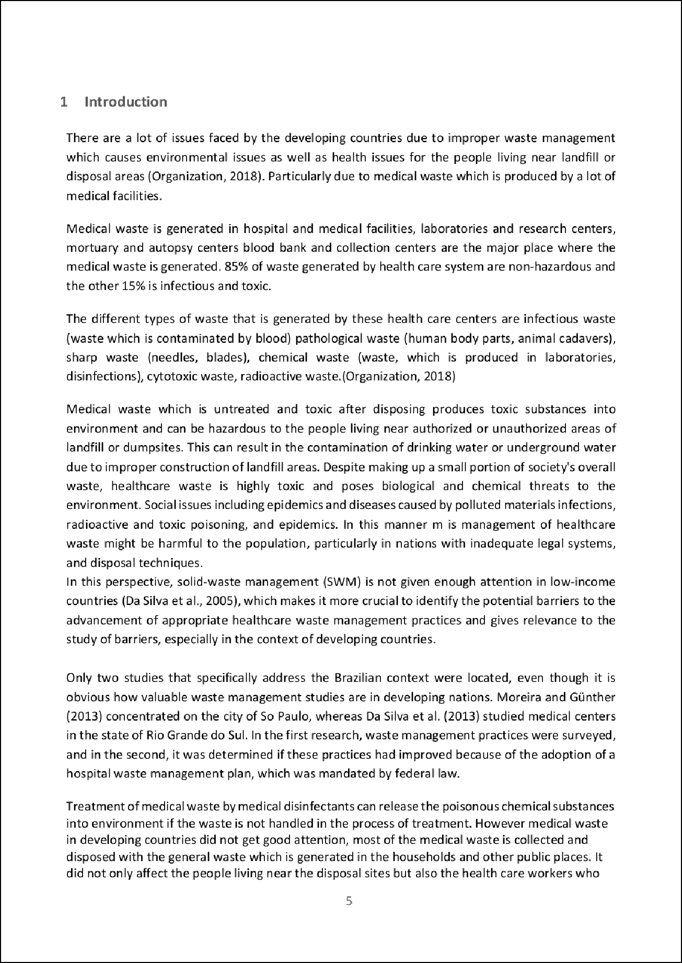

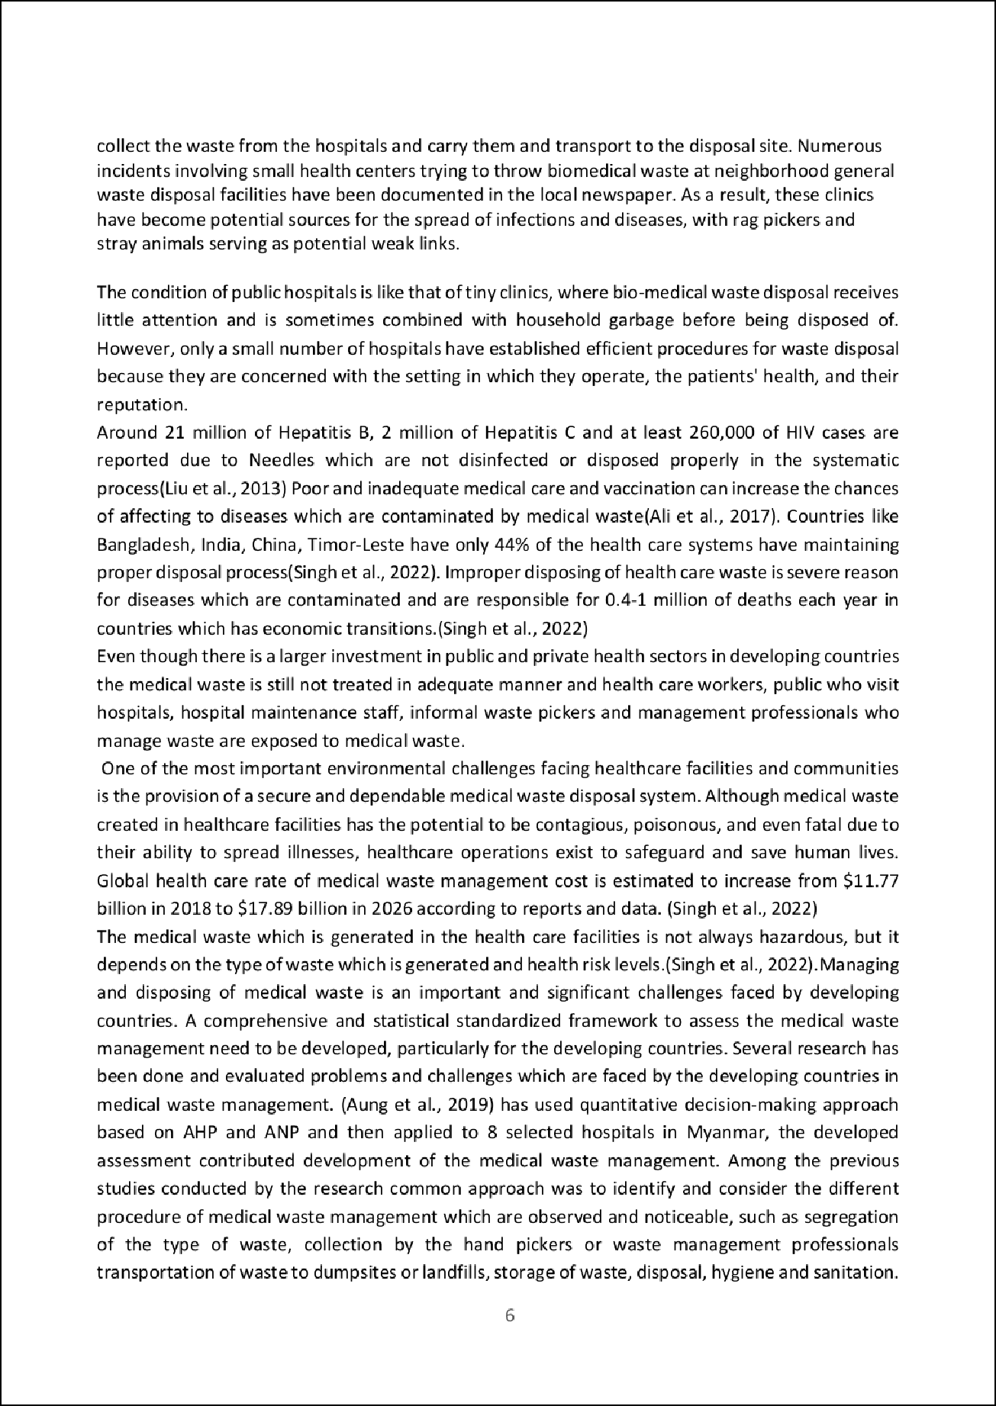

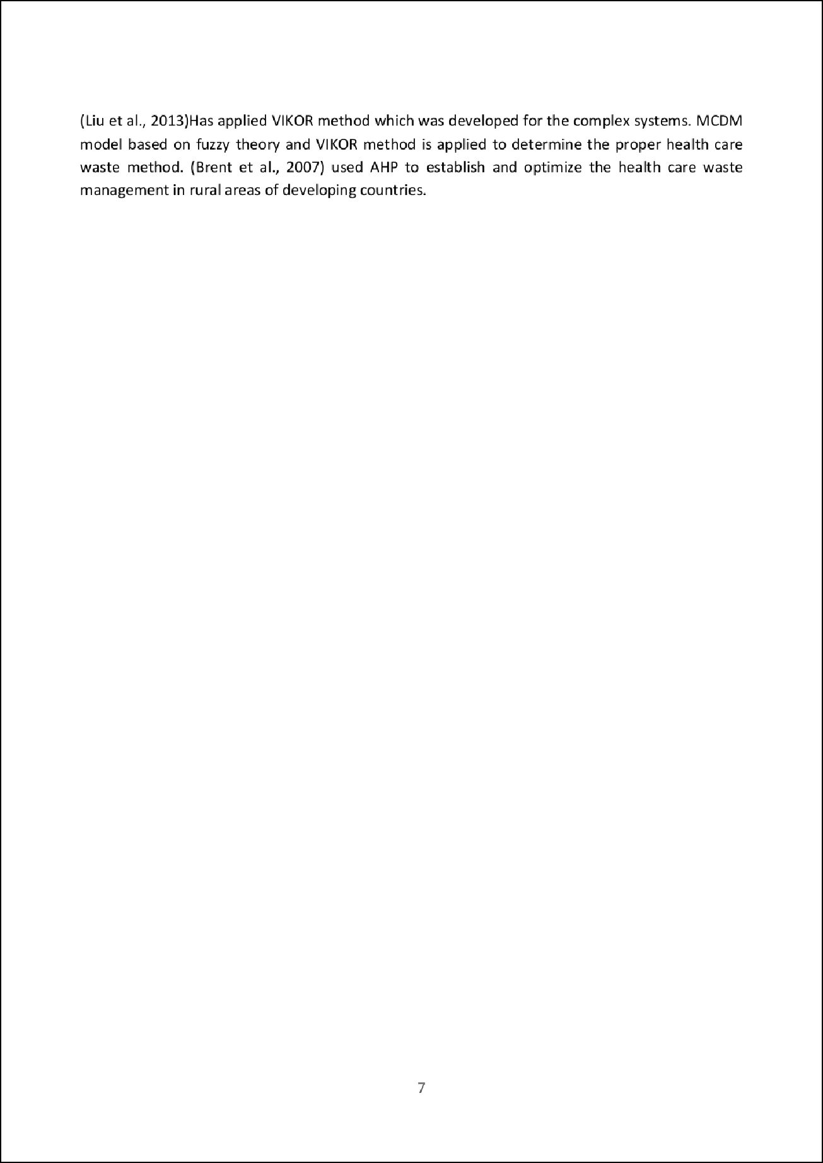

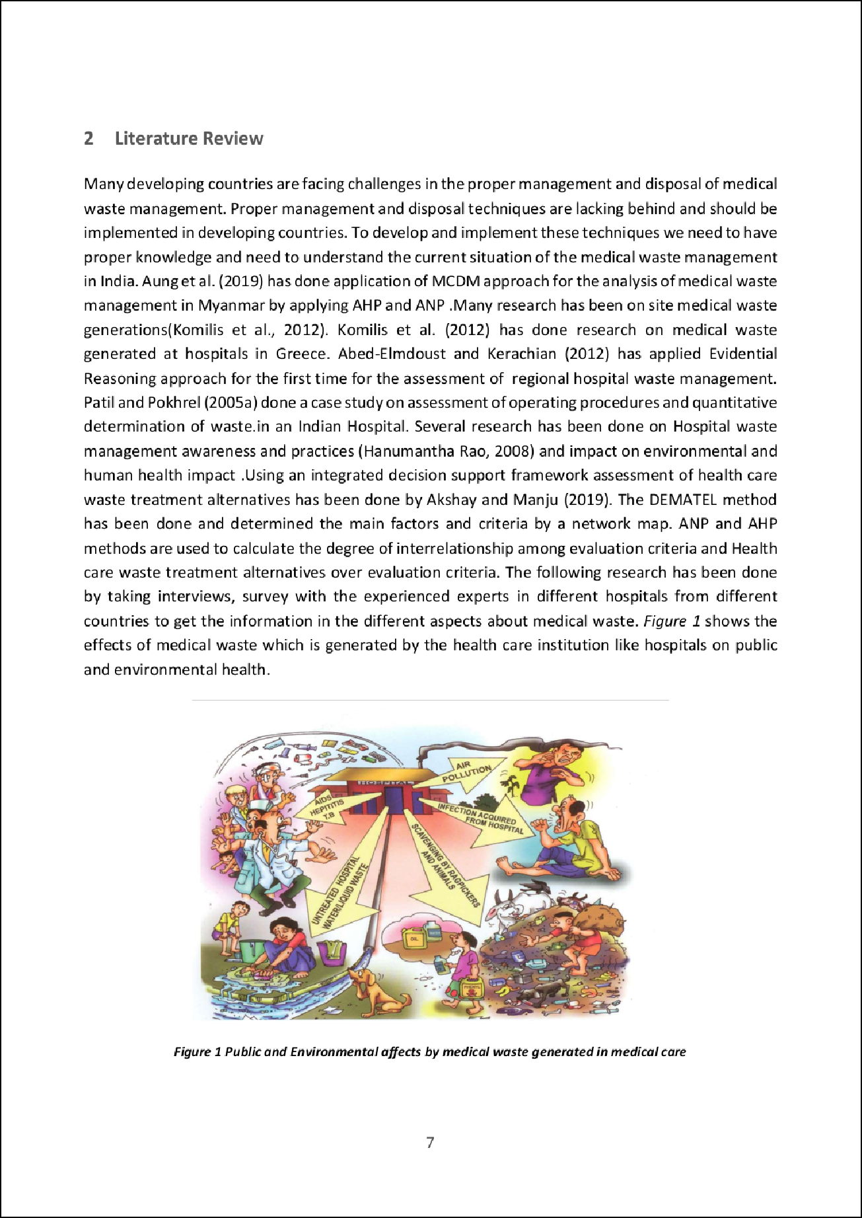

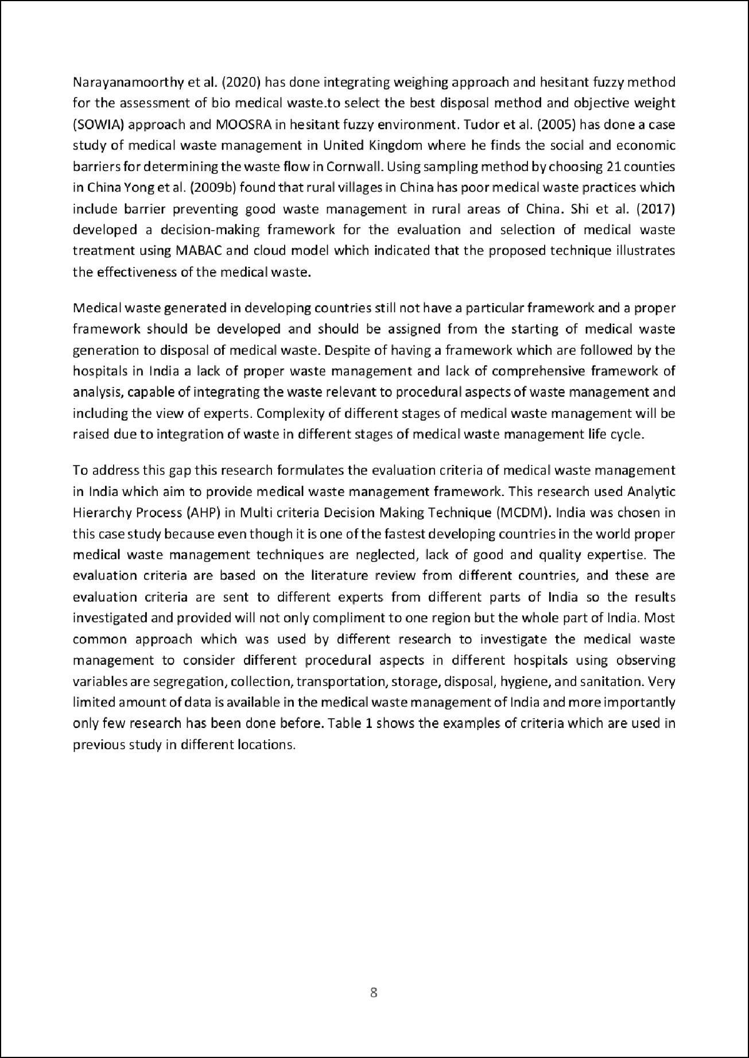

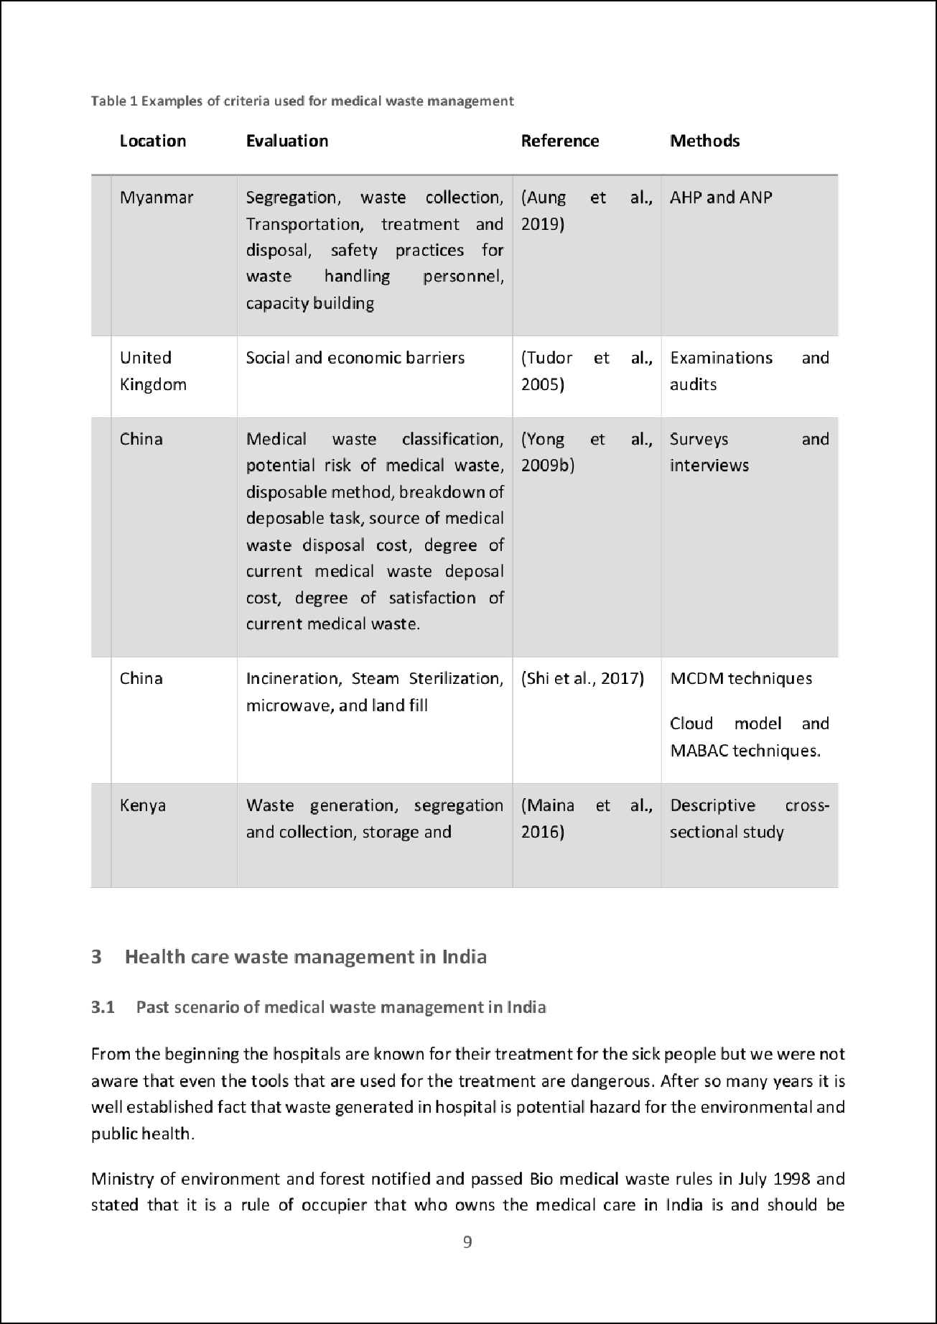

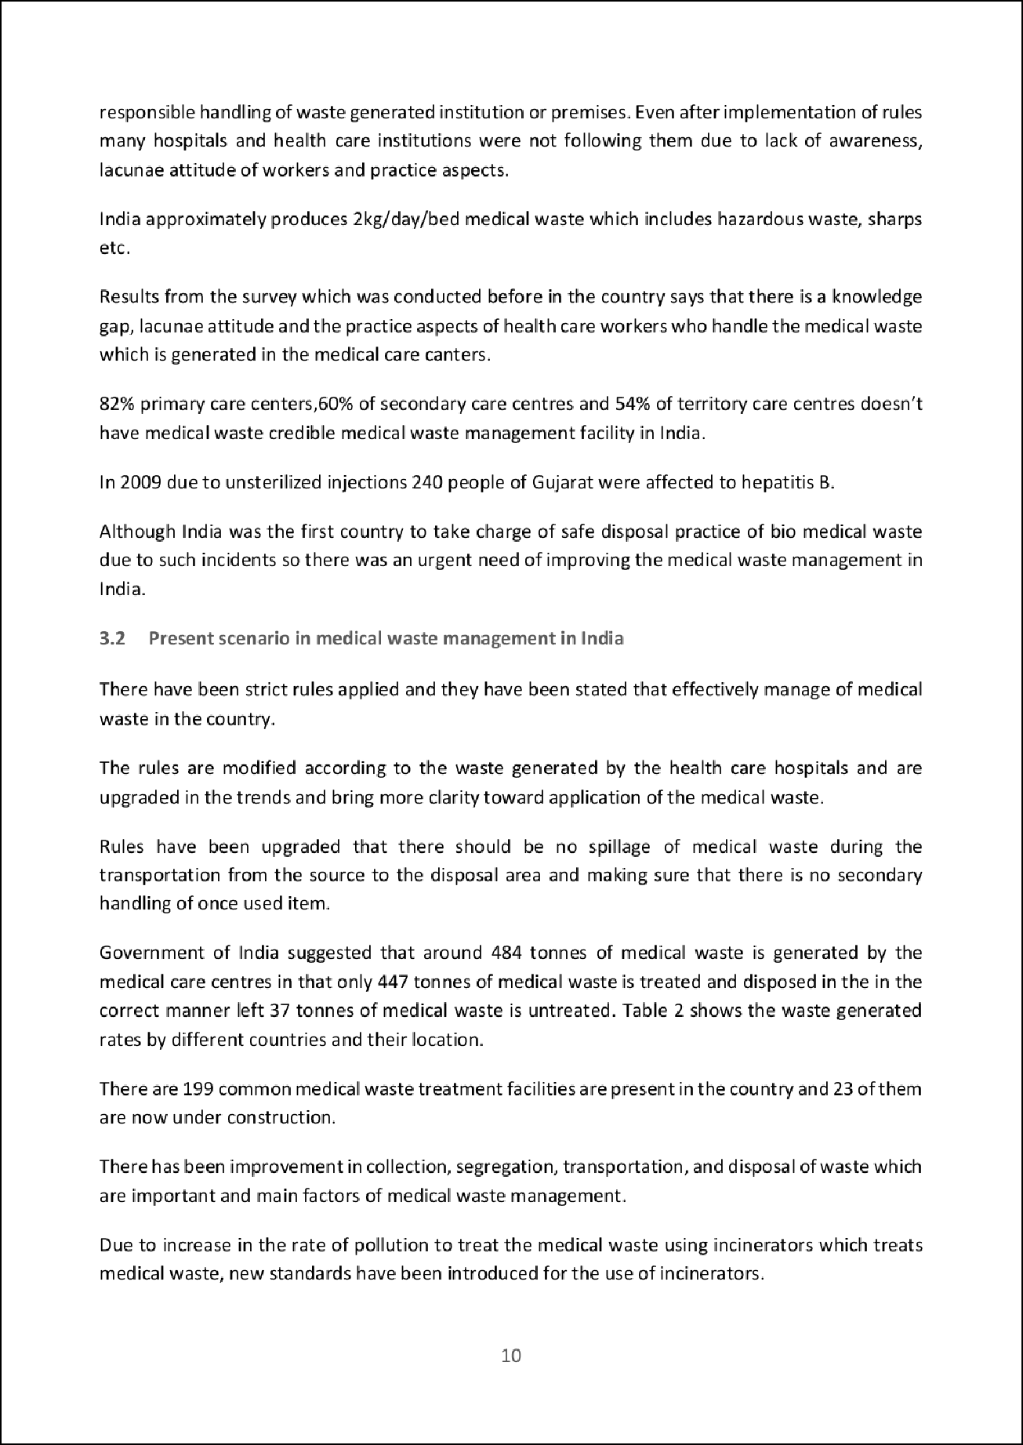

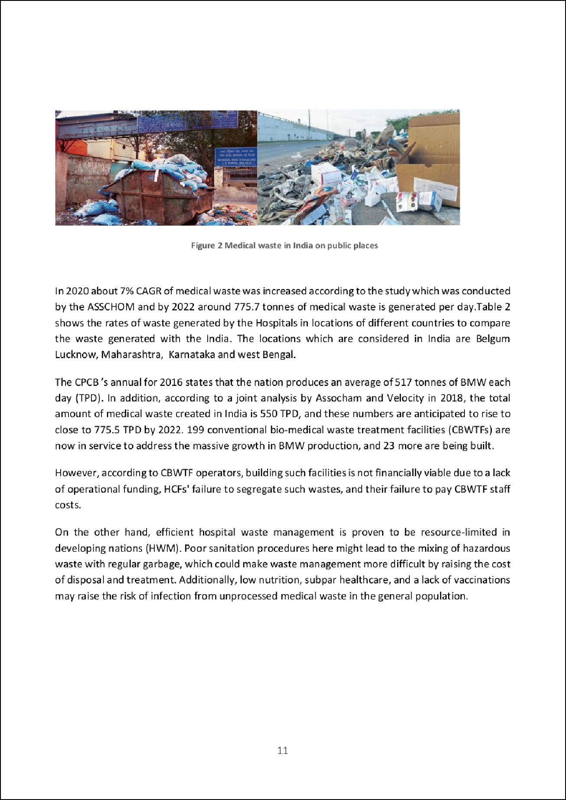

A country's GDP per capita is the gross value of all goods and services produced per year, measured in a common currency and then divided by the population of the country. The nominal GDP data presented in is from the World Bank, and is based on the 2012 calendar year, except the data for Taiwan, which is from the IMF's GDP data for 2012 due to the World Bank not listing data for Taiwan.

**Healthcare spending per capita**

Healthcare spending per capita is calculated by taking the percentage of GDP for each country that is spent on healthcare, retrieved from World Bank 2012 data, and then multiplying this percentage by each county's per capita GDP. Healthcare spending includes both public and private expenditures on health services (preventive and curative), family planning activities, nutrition activities, and emergency aid designated for health. Data for Taiwan was unavailable.

**Healthcare system performance**

The overall health system performance of 191 countries was ranked by the World Health Organization in the year 2000 as part of their World Health Report for the new millennium. The countries were ranked on three key criteria, these being:

•

Disability-adjusted life expectancy – average (25%) and equality of distribution (25%)

•

Healthcare system responsiveness – average responsiveness (12.5%) and equality of responsiveness (12.5%)

•

Fair financial contribution (25%)

The WHO healthcare system ranking of selected countries is displayed in, and is used in this report as indicative of the quality of healthcare provided in each listed country.

#### **Data presentation and analysis**

Using the three data sets described above, comparisons can be made between the quantity of both infectious and non-infectious healthcare waste generated (measured in kg/bed-day) against per capita GDP, healthcare spending GDP, and the quality of the healthcare system across different countries. All data are summarized in.

The relation between the amounts of medical waste generated in kg/bed-day against each country's GDP per capita is shown in, with all countries displayed as ○ except for the United States and Jordan, which are displayed as Δ.  shows the amount of medical waste generated in kg/bed-day against each country's healthcare spending per capita, with the same symbols used

Healthcare waste incineration standards in the United States became stricter in November 1990, when the United States Congress passed amendments to the [Clean Air Act](https://www-sciencedirect-com.ezproxy3.lib.le.ac.uk/topics/engineering/clean-air-act), establishing emission limits for, among other [pollutants](https://www-sciencedirect-com.ezproxy3.lib.le.ac.uk/topics/social-sciences/pollutant), dioxins, furans and mercury (Hg). These additions to the Clean Air Act were crafted to encourage the adoption of [pollution control equipment](https://www-sciencedirect-com.ezproxy3.lib.le.ac.uk/topics/earth-and-planetary-sciences/pollution-control-equipment) on source exhausts, as the new limits in the act were based on the maximum achievable pollution reduction through control technology. American regulations then targeted emissions from municipal and healthcare waste incineration, after the EPA released its 1994 inventory of dioxin emission sources, which identified healthcare [waste incinerators](https://www-sciencedirect-com.ezproxy3.lib.le.ac.uk/topics/earth-and-planetary-sciences/waste-incinerator) as the leading source of dioxin and furan emissions in America . Based on the EPA's findings and their own research, most developed nations have followed the American example and have attempted to reduce their dioxin and furan emissions from waste incineration.

### **Medical waste transportation**

Medical waste transportation refers to the [haulage](https://www-sciencedirect-com.ezproxy3.lib.le.ac.uk/topics/earth-and-planetary-sciences/haulage) and handling of waste from inside healthcare facilities to treatment sites, which can either exist on-site at a hospital or be a central off-site facility. A second transportation phase typically occurs when the treated [waste residual](https://www-sciencedirect-com.ezproxy3.lib.le.ac.uk/topics/earth-and-planetary-sciences/residual-waste), typically ash from an incinerator or waste sterilized through autoclaving or microwaving, is moved to a landfill for final disposal. It is common practice for healthcare facilities to have their infectious waste stream transported by a third-party firm, contracted to take the waste from the healthcare facility to an appropriate waste depot. These firms typically collect the waste from a few central points in a healthcare facility and then transport the waste to a disposal facility that is able to safely handle medical waste. However, there are issues with the process of contracting out waste disposal.

The use of third party disposal firms poses a challenge from an incentives point of view, as the waste disposal firms, or the individuals who work for them, can pocket large sums by improperly disposing of the waste. Disposal fees for medical waste in developed countries are very high, with hospitals in the UK frequently paying in excess of £450 per tonne for contractors to dispose of their medical waste and hospitals in the United States typically paying $790 per tonne for medical waste disposal. These high prices create an incentive for third-party medical waste haulage firms to dispose of the medical waste without treatment in unregulated and less expensive ways, rather than transport the waste to a proper treatment facility for sterilization. In Ireland, waste truck operators can pocket over $2000 by illegally dumping a truck full of medical waste rather than taking it to a regulated disposal site, thus creating a very strong incentive for illegal dumping. Developed nations are increasingly having to grapple with the problem of illegal medical waste dumping, which can be particularly chronic if the country has a weak infectious medical waste tracking system. Illegal dumping is a significant issue, as these untreated infectious waste deposits present a health risk to the public due to potential for pathogen release, and a drain public funds as cleanup costs for medical wastes are extremely high.

The leading method of disposing infectious medical waste in developed nations is through incineration, whereby the wastes are burned at very high temperatures so that nothing but a residual ash remains. This ash is then sent to a landfill facility to be buried. Incineration has the advantage of ensuring sterilization by reducing the infectious waste to an unrecognizable ash, and of reducing waste volumes which reduces transport and landfill impacts and costs. However, a major drawback of the medical waste [incineration process](https://www-sciencedirect-com.ezproxy3.lib.le.ac.uk/topics/engineering/incineration-process) is the release of undesirable toxins into the atmosphere. Because of its composition, infectious healthcare waste produces toxic gases in meaningful quantities when incinerated, and thus incinerator emissions are tightly regulated in most developed nations. The three toxins that are of greatest concern with medical waste incineration are dioxins, furans, and mercury

Research has shown that one of the major issues associated with incineration of infectious waste from healthcare facilities is the formation of dioxins, furans, and similar compounds during the combustion process ([Verma, 2014](https://www-sciencedirect-com.ezproxy3.lib.le.ac.uk/science/article/pii/S0301479715302176" \l "bib64)). Dioxins are organic compounds with two [benzene rings](https://www-sciencedirect-com.ezproxy3.lib.le.ac.uk/topics/engineering/benzene-ring) connected by two oxygen atoms, and contain four to eight chlorines substituted for [hydrogen atoms](https://www-sciencedirect-com.ezproxy3.lib.le.ac.uk/topics/earth-and-planetary-sciences/hydrogen-atom) on the benzene rings ([Schecter et al., 2006](https://www-sciencedirect-com.ezproxy3.lib.le.ac.uk/science/article/pii/S0301479715302176" \l "bib48)). Dioxins are extremely persistent toxins, with an estimated half-life in humans of 7–11 years, and result primarily from human activity. They are known to be highly carcinogenic and to cause reproductive harm in humans ([Environment Canada, 2013](https://www-sciencedirect-com.ezproxy3.lib.le.ac.uk/science/article/pii/S0301479715302176" \l "bib21), [Schecter et al., 2006](https://www-sciencedirect-com.ezproxy3.lib.le.ac.uk/science/article/pii/S0301479715302176#bib48)). Furans are structurally similar to dioxins, but with only one oxygen atom between the two benzene rings, and have similarly toxic properties. Hereafter in this paper, the term dioxin is used to refer to dioxin, furan, and similar compounds.

The United States EPA estimates that medical waste incineration emitted 2570 g [toxicity](https://www-sciencedirect-com.ezproxy3.lib.le.ac.uk/topics/social-sciences/toxicology) equivalence (TEQ) of dioxin in 1987, representing 18 percent of total atmospheric anthropogenic dioxin emissions. By 2000, the dioxin emissions from medical waste incineration facilities were down 85 percent from 1987 levels to 378 g TEQ, or 27 percent of total anthropogenic dioxin emissions that year ([National Center for Environmental Assessment, 2006](https://www-sciencedirect-com.ezproxy3.lib.le.ac.uk/science/article/pii/S0301479715302176" \l "bib42)). The EPA notes that while the individual dioxin emissions from each of the over 6000 medical waste incinerators in the United States is relatively small, the large number of facilities means that their collective contribution to atmospheric dioxin levels is quite large. In fact, the small size of most waste incinerators used by hospitals increases total atmospheric dioxin emissions from infectious medical waste disposal, as these smaller incinerators are not equipped with the highly sophisticated dioxin control technologies that larger incineration facilities can afford (EPA [Exposure Assessment Group, 1994](https://www-sciencedirect-com.ezproxy3.lib.le.ac.uk/science/article/pii/S0301479715302176" \l "bib23)).

In Canada, waste incineration has historically been responsible for a significant portion of atmospheric dioxin emissions. Despite Canada greatly tightening its [air quality standards](https://www-sciencedirect-com.ezproxy3.lib.le.ac.uk/topics/engineering/air-quality-standard) over the past several decades, dioxin emissions from waste incineration facilities remain the second largest source of dioxin emissions and are estimated to account for 22.5% of total dioxin emissions within the country ([Environment Canada, 2013](https://www-sciencedirect-com.ezproxy3.lib.le.ac.uk/science/article/pii/S0301479715302176#bib21)).

It is important to note that these macro-scale emission figures that are reported, do not give a full picture regarding the impact of emissions associated with incineration facilities. Indeed, the percentage increase in airborne dioxin levels that are experienced by people living near incineration facilities, is substantially higher than the increase in overall atmospheric concentration ([Batterman, 2004](https://www-sciencedirect-com.ezproxy3.lib.le.ac.uk/science/article/pii/S0301479715302176" \l "bib5)). This is of particular concern as developing nations frequently burn medical waste in uncontrolled conditions and without any [flue gas treatment](https://www-sciencedirect-com.ezproxy3.lib.le.ac.uk/topics/earth-and-planetary-sciences/flue-gas-treatment) systems, leading to high levels of dioxin emissions from these waste disposal facilities ([Ananth et al., 2010](https://www-sciencedirect-com.ezproxy3.lib.le.ac.uk/science/article/pii/S0301479715302176" \l "bib3)). Therefore, populations living near medical waste incineration facilities in developing nations are frequently exposed to very high dioxin levels.

#### **6.2.2. Mercury emissions**

[Incineration of waste](https://www-sciencedirect-com.ezproxy3.lib.le.ac.uk/topics/earth-and-planetary-sciences/incineration-of-waste), both medical and municipal, is estimated to represent 13 percent of anthropogenic mercury emissions in North America, making it second only to [coal combustion](https://www-sciencedirect-com.ezproxy3.lib.le.ac.uk/topics/earth-and-planetary-sciences/coal-combustion) (at 55 percent) as an emissions source ([Pacyna et al., 2006](https://www-sciencedirect-com.ezproxy3.lib.le.ac.uk/science/article/pii/S0301479715302176" \l "bib45)). In Canada, infectious medical waste incinerators are estimated to account for 9 percent of annual atmospheric mercury emissions ([Weir, 2002](https://www-sciencedirect-com.ezproxy3.lib.le.ac.uk/science/article/pii/S0301479715302176" \l "bib67)). Further, at least 3 percent of global anthropogenic mercury emissions come from waste incineration ([Pacyna et al., 2006](https://www-sciencedirect-com.ezproxy3.lib.le.ac.uk/science/article/pii/S0301479715302176#bib45)). Atmospheric mercury emissions pose a significant health and environmental risk, as airborne mercury can readily enter the body through the lungs where it accumulates in fatty tissue. This is concerning, as elevated [mercury levels](https://www-sciencedirect-com.ezproxy3.lib.le.ac.uk/topics/engineering/mercury-level) in the body have been shown to damage the nervous, excretory and reproductive systems ([Wolfe et al., 1998](https://www-sciencedirect-com.ezproxy3.lib.le.ac.uk/science/article/pii/S0301479715302176" \l "bib68)).

### **6.3. Emissions control**

According to the U.S. EPA Office of Air Quality Planning and Standards, [atmospheric emissions](https://www-sciencedirect-com.ezproxy3.lib.le.ac.uk/topics/earth-and-planetary-sciences/atmospheric-emission) of dioxins and mercury are the pollutants associated with waste incineration of greatest environmental concern ([Kilgroe, 1996](https://www-sciencedirect-com.ezproxy3.lib.le.ac.uk/science/article/pii/S0301479715302176" \l "bib32)). The two leading methods for dioxin emission control from incineration facilities are fabric filter bag houses and [dry scrubbers](https://www-sciencedirect-com.ezproxy3.lib.le.ac.uk/topics/engineering/dry-scrubber) in combination with [electrostatic precipitators](https://www-sciencedirect-com.ezproxy3.lib.le.ac.uk/topics/earth-and-planetary-sciences/electrostatic-precipitator). However, the use of fabric filters is generally accepted to be a more effective method of dioxin control ([Kilgroe, 1996](https://www-sciencedirect-com.ezproxy3.lib.le.ac.uk/science/article/pii/S0301479715302176#bib32)). Further, incinerator operating conditions play an important role in dioxin emission levels, with dioxin formation greatly increasing when combustion is incomplete due to lack of oxygen or when combustion occurs as temperatures below 800 °C. [Flue gas](https://www-sciencedirect-com.ezproxy3.lib.le.ac.uk/topics/earth-and-planetary-sciences/flue-gas) temperatures in the range of 250 °C–450 °C must also be avoided ([World Health Organization, 2011](https://www-sciencedirect-com.ezproxy3.lib.le.ac.uk/science/article/pii/S0301479715302176" \l "bib70)). By operating incineration facilities at optimal conditions the dioxin emissions associated with medical waste incineration can be greatly reduced.

The control of mercury emissions commonly involves injecting [powdered activated carbon](https://www-sciencedirect-com.ezproxy3.lib.le.ac.uk/topics/engineering/powdered-activated-carbon) into the flue gas stream, onto which the gas-phase mercury adsorbs. The particles of carbon onto which the gaseous mercury has been adsorbed can then be removed using such [particulate matter control](https://www-sciencedirect-com.ezproxy3.lib.le.ac.uk/topics/engineering/particulate-matter-control) technologies as fabric filters or electrostatic precipitators ([Kilgroe, 1996](https://www-sciencedirect-com.ezproxy3.lib.le.ac.uk/science/article/pii/S0301479715302176#bib32)).

## **7. Future directions**

The following section discusses autoclave [waste treatment](https://www-sciencedirect-com.ezproxy3.lib.le.ac.uk/topics/earth-and-planetary-sciences/sewage-treatment) as an alternative to incineration. In addition, substituting medical products with those that are less detrimental when incinerated and the need for better hospital waste sorting practices are put forward as areas for future improvement. All of these possibilities have the potential to mitigate the growing problem of infectious medical waste disposal.

### **7.1. Autoclave waste treatment**

Considering the high costs and [environmental impacts](https://www-sciencedirect-com.ezproxy3.lib.le.ac.uk/topics/social-sciences/human-activities-effects) of medical waste disposal through incineration, many researchers and firms are devoted to developing alternate treatment methods for infectious medical wastes. The leading alternative to waste incineration is autoclaving, a process whereby infectious waste is treated with the addition of dry heat or steam to raise the temperature of infectious waste to levels sufficient to [kill microbial](https://www-sciencedirect-com.ezproxy3.lib.le.ac.uk/topics/engineering/microbial-kill) contamination, with these systems generally operating at temperatures between 121 and 163 °C ([Lee et al., 2004](https://www-sciencedirect-com.ezproxy3.lib.le.ac.uk/science/article/pii/S0301479715302176" \l "bib36)). After treatment, the autoclaved waste can be taken to a municipal solid waste (MSW) landfill site and disposed of in the same manner as non-infectious waste ([Klangsin and Harding, 1998](https://www-sciencedirect-com.ezproxy3.lib.le.ac.uk/science/article/pii/S0301479715302176" \l "bib33)).

Autoclave treatment of infectious medical waste is considered environmentally advantageous when compared with incineration, as it does not release the poisonous dioxin and mercury emissions into the atmosphere ([Lee et al., 2004](https://www-sciencedirect-com.ezproxy3.lib.le.ac.uk/science/article/pii/S0301479715302176#bib36)). However, there are drawbacks to the use of autoclaving as an infectious waste treatment method. Because autoclave treatment merely heats the waste to sufficient temperature to kill pathogens, the waste does not change in appearance after autoclave treatment, giving the appearance that untreated infectious waste is being disposed of in landfill sites ([Klangsin and Harding, 1998](https://www-sciencedirect-com.ezproxy3.lib.le.ac.uk/science/article/pii/S0301479715302176#bib33)). As a result, autoclaved waste is often re-treated via incineration before final disposal due to the reluctance of many communities to allow non-incinerated infectious waste into their landfills, making the autoclave treatment redundant ([Jang et al., 2005](https://www-sciencedirect-com.ezproxy3.lib.le.ac.uk/science/article/pii/S0301479715302176" \l "bib31)). This double treatment of infectious medical waste unnecessarily increases the cost of disposal and creates needless environmental impacts due to the use of energy in the autoclaving process.

Another argument against autoclaving infectious waste is that it does not significantly reduce the volume of waste to be landfilled, whereas incineration leaves only 20 to 30 percent of the original waste volume behind as ash, greatly reducing the amount of space the waste occupies in a landfill ([Verma, 2014](https://www-sciencedirect-com.ezproxy3.lib.le.ac.uk/science/article/pii/S0301479715302176#bib64)). However, the drawbacks of autoclave infectious medical waste treatment must be considered alongside the drawbacks of medical waste incineration. The macro-scale benefit of waste volume reduction in the incineration treatment method may be dubious, as medical waste represents a very small fraction of the total volume of waste generated per year compared to other types of waste sent to landfill ([Cheng et al., 2009](https://www-sciencedirect-com.ezproxy3.lib.le.ac.uk/science/article/pii/S0301479715302176" \l "bib16)).

A variation of autoclave treatment is [microwave treatment](https://www-sciencedirect-com.ezproxy3.lib.le.ac.uk/topics/engineering/microwave-treatment), which involves a process similar to the [autoclave process](https://www-sciencedirect-com.ezproxy3.lib.le.ac.uk/topics/engineering/autoclave-process) outlined above but instead uses microwaves to add heat ([Lee and Huffman, 1996](https://www-sciencedirect-com.ezproxy3.lib.le.ac.uk/science/article/pii/S0301479715302176" \l "bib35)). However, one major difference between microwaving and autoclaving waste is that with microwaves, metal cannot be present in the waste, as microwaves impacting on metal can cause large, potentially dangerous sparks. Further, some question the ability of the microwave process to sufficiently reduce the pathogen content of infectious medical waste ([Lee et al., 2004](https://www-sciencedirect-com.ezproxy3.lib.le.ac.uk/science/article/pii/S0301479715302176#bib36)).

### **7.2. Medical equipment substitution**

Literature suggests that incineration is likely to remain a prominent method of infectious medical waste disposal, which has prompted some researchers to suggest that medical equipment suppliers should create products that can be incinerated without releasing dioxins or mercury ([Lee et al., 2004](https://www-sciencedirect-com.ezproxy3.lib.le.ac.uk/science/article/pii/S0301479715302176#bib36)). Indeed, it has been shown that reducing the amount of dioxin precursor-compounds in waste entering an incinerator can limit dioxin pollution from incineration facilities, hence material substitutions by medical product manufacturers could be reasonably expected to achieve incinerator dioxin emission reductions ([Buekend and Huang, 1998](https://www-sciencedirect-com.ezproxy3.lib.le.ac.uk/science/article/pii/S0301479715302176" \l "bib10)). Materials containing [polyvinyl chloride](https://www-sciencedirect-com.ezproxy3.lib.le.ac.uk/topics/earth-and-planetary-sciences/polyvinyl-chloride) (PVC) are the leading source of chlorine content in medical wastes, and the presence of chlorine in waste is suspected to be the leading cause for the high dioxins emissions from waste incineration facilities ([Thorton et al., 1996](https://www-sciencedirect-com.ezproxy3.lib.le.ac.uk/science/article/pii/S0301479715302176" \l "bib56)). Therefore, medical equipment suppliers should strive to reduce or eliminate PVCs from their products as this would almost certainly lead to a reduction in dioxin emissions associated with infectious waste incineration ([Thorton et al., 1996](https://www-sciencedirect-com.ezproxy3.lib.le.ac.uk/science/article/pii/S0301479715302176#bib56)). Reducing the amount of PVCs disposed of by hospitals in infectious waste would be a significant challenge, as PVCs are a prevalent material in medical products. As a result, any attempt at PVC elimination would require manufactures to find substitute materials for PVCs, and healthcare providers may be reluctant to adopt these substitutes if they perceive any compromise in equipment performance.

